**I. Approved Signature:**

|  |  |
| --- | --- |
| http://wnsm/Pics/emailsignatureLogo2018B.jpg | **FIRST LAST** Your Title Here  **o.** 555.555.5555 x007 | **c.** 555.867.5309 555 Name Street, Suite 555 ChangeThisCityName, ID 55555 [www.nsm-seating.com](http://www.nsm-seating.com/)  **MOBILITY** ● **ACCESSIBILITY** ● **SERVICE** |

**II. Styling Guidelines:**

*Please note, the styling *should* transfer when copy and pasting from Word to Outlook but please use the below guidelines if needed.

Size

* Name: font size 11
* Title: font size 10
* Information: font size 9
* Mobility/Accessibility/Service: font size 9

Color

* Name: RGB 29, 79, 145
* Title: RGB 65, 182, 230
* Information: RGB 128, 128, 128
* Mobility: RGB 45, 111, 183
* Accessibility: RGB 65, 182, 230
* Service: RGB 29, 79, 145

Font

* Please use a clean font like Arial or Calibri

**III. Instructions:**

**STEP 1:**  Select the approved NSM email signature pictured above and then “Copy”. Please be sure to select all content including the logo and name information.

**STEP 2:**  Open Outlook and Click on “New Email”

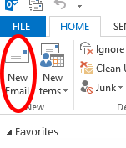

**STEP 3:**  Click on “Signature” and choose “Signatures” in the dropdown box.

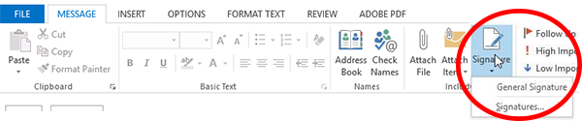

**STEP 4:**  In the “Select signature to edit” box, select all signatures and click the “Delete” button. Then, click “New” button and name the new signature.

**STEP 5:** Now, “Paste” the new signature in the open field and edit the content to be your personal contact information.  Your name should be ALL CAPS.  When finished click the “Save” button.

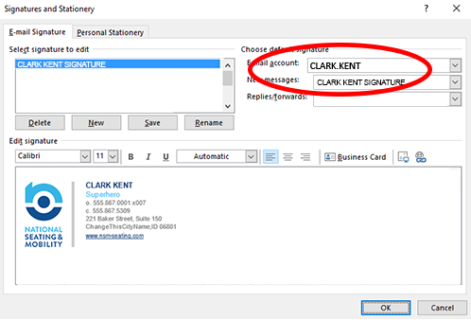

**STEP 6:**  Before clicking the “OK” button, choose the new signature you just created for the “New messages”. You can follow the same process to place a shorter signature on "Replies / Forwards".

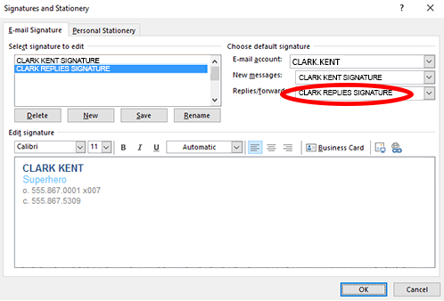

Approved "Replies/Forward" Signature is to the left.

**STEP 7:** To test whether it worked or not, open a new email and you should see your new signature in the text box.