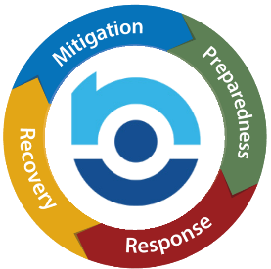

Emergency Operations Plan 2025 – Planning In-Service

In order to create an effective Emergency Operations Plan, it is important that all staff members participate in the development of your plan. Involve all staff members in the discussion about how to best respond to emergencies from their perspective. Participating in the planning will help everyone know and understand what part they play in continuing operations in an emergency.

Reviewing how your plan held up in action will be part of a separate session. This meeting is intended to create the actual plan as a team.

Branch Name/Number:

Date of EOP Planning In-Service:

Who led the Planning In-Service?

Did everyone understand their role and contribute to the plan?
Who attended? | (Use a second page if needed)
Print Name Below: | Sign Below:

Forward a copy of the completed in-service form and any additional pages to compliance@nsm-seating.com .

Who was not present for the in-service? |  | Were you informed of the plan and given the opportunity to participate in the review?
Print Name Below: | Sign Below:

Forward a copy of the completed review and any additional pages to compliance@nsm-seating.com .

