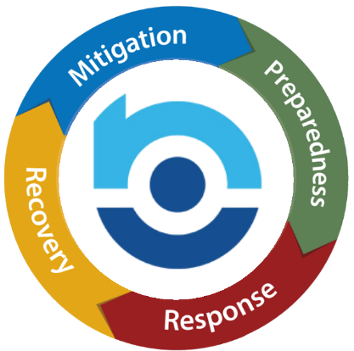

EMERGENCY OPERATIONS

2025 Post-Event Review or Drill

To help you evaluate the effectiveness of your emergency management plan, provide detailed answers to the questions below. If you have an actual event that activates your plan, your review can be of the response to the actual event. If you’re performing a drill, the event chosen must stress the plan to the point that all or most elements of the plan are activated. All staff members, including those who work remotely, should be involved in the discussion about how effective the plan was from their perspective. Their involvement should be confirmed by their signature at the end of this form. Reviewing how your plan held up in action will help identify possible improvements to ensure that operations can continue in the event of future emergencies.

Forward a copy of the completed review to the Compliance Department at Compliance@nsm-seating.com.

Branch Name/Number: ______________________________________________________

Emergency Coordinator: ____________________________________________________

Date of Event or Drill: _______________________________________________________

This was an actual Event. This was a Drill.

Type of Event - Provide a detailed narrative describing the type of emergency experienced and your response. Attach additional sheets as needed.  Fire Drill or Infectious Disease Influx may not be used as a Drill. | (Fire Drill or Infectious Disease Influx may not be used as a Drill.)

Did the event happen during business hours?

Were all employees contacted? Was the phone list effective?

Did all employees feel adequately informed?

Was the building evacuated?

Was the location operable?

How long were operations disrupted?

Was client contact needed? Was it carried out quickly?

Did you require home office assistance? Was it effective & timely?

Did you require assistance from other NSM locations or other providers? Which ones and how effective were they?

What went well with the plan?

Were there any areas that should be better addressed in the future?

Other Comments/Questions:

After the review is complete and has been discussed with everyone involved in the event, send a copy to the Compliance Department. A follow up discussion will be scheduled as needed.

Post-Event Review or Drill Participation Sign-In Sheet
Who participated in the drill/post-event review? (Only employees on vacation or leave should be excluded.) | (Use a second page if needed)
Print Name Below: | Sign Below:

