**How to Complete BCBST Self-Guided Tobacco Cessation Programs**

Log into [www.bcbst.com](http://www.bcbst.com)

Click on Log In/Register

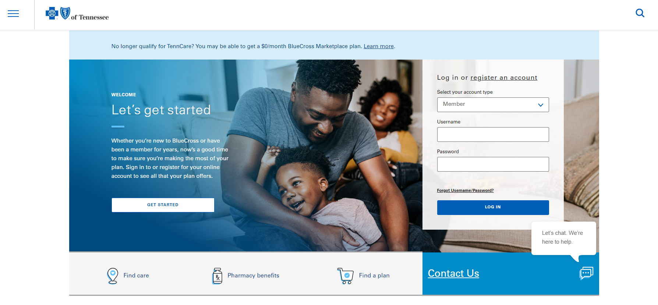

Log In or Register.

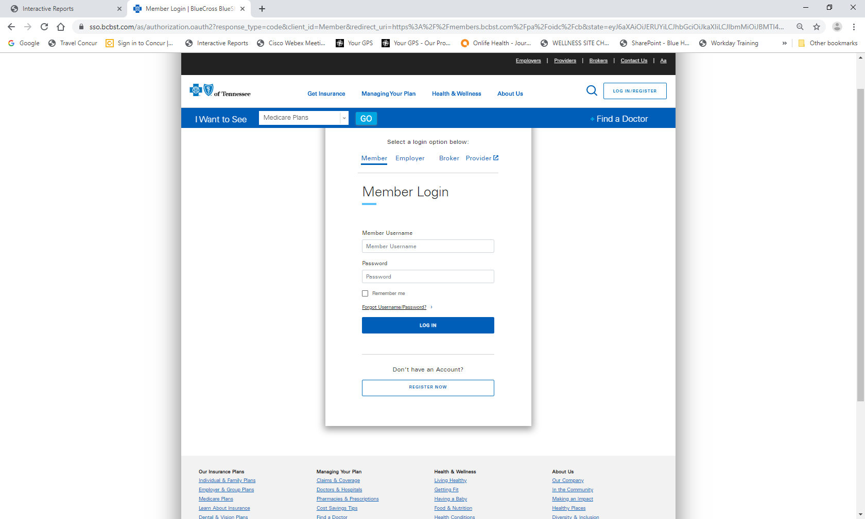

Hover over the ‘Managing Your Health’ Tab and click ‘Member Wellness Center’.

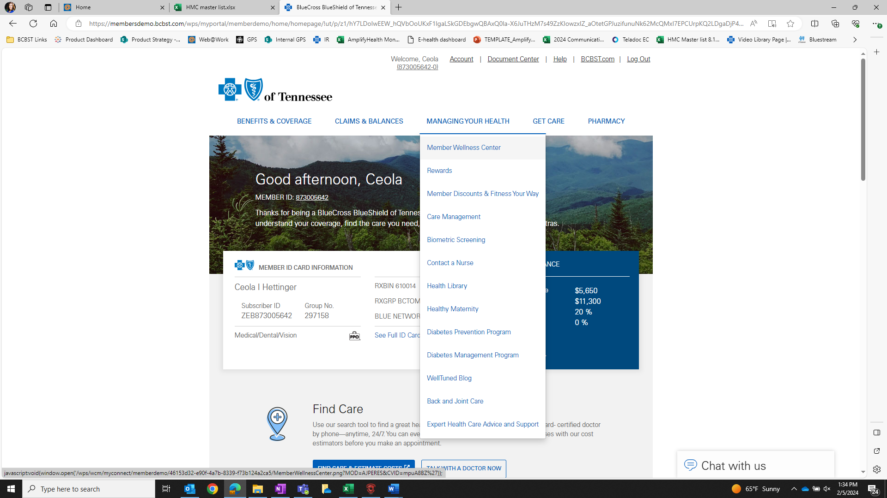

Click on ‘I’ll do this later’ or go ahead and take your Personal Health Assessment.

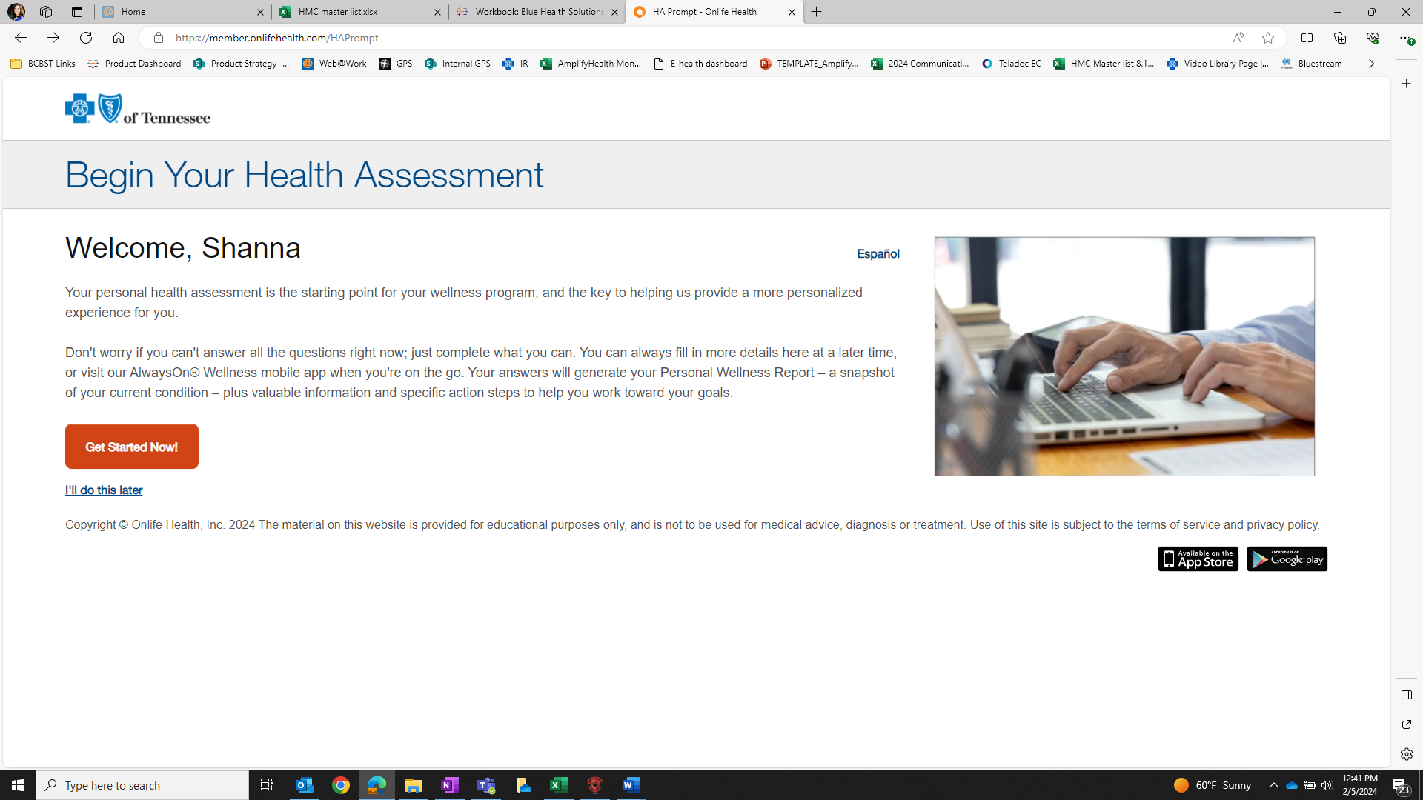

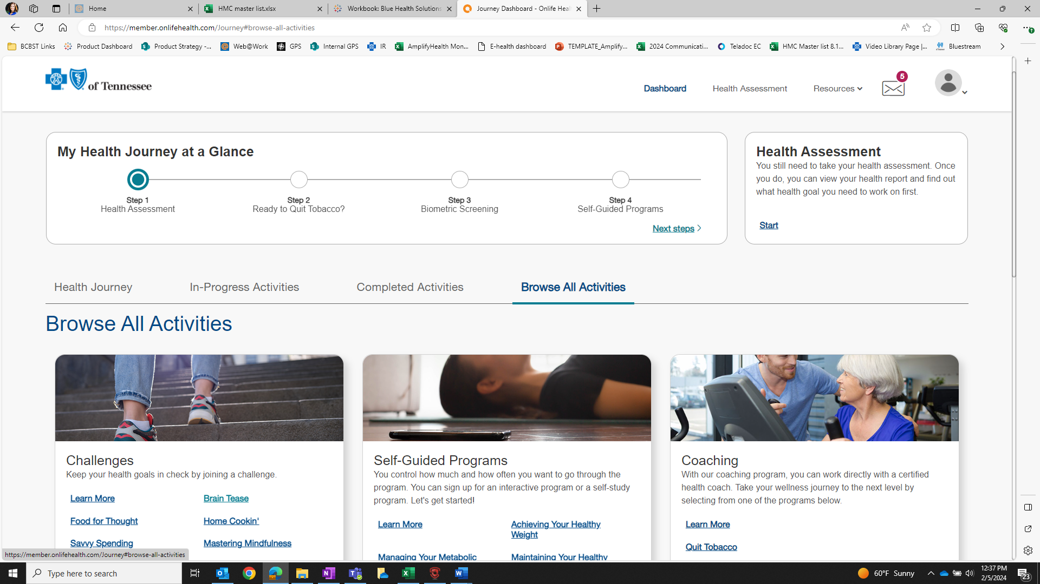

On the home page of the Member Wellness Center, click ‘Browse All Activities’. You can view and access Self-Guided Programs here, including the Tobacco programs.

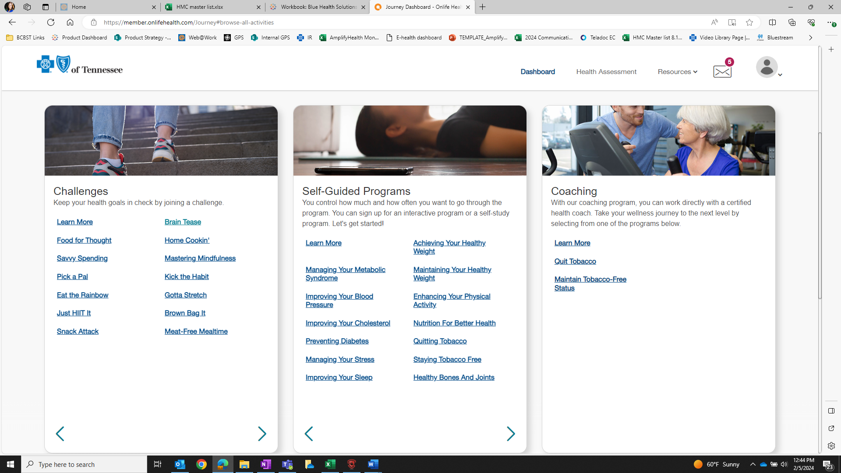

Choose ‘Quitting Tobacco’ or ‘Staying Tobacco Free’ and then ‘Get Started!’ to complete the six-week program.

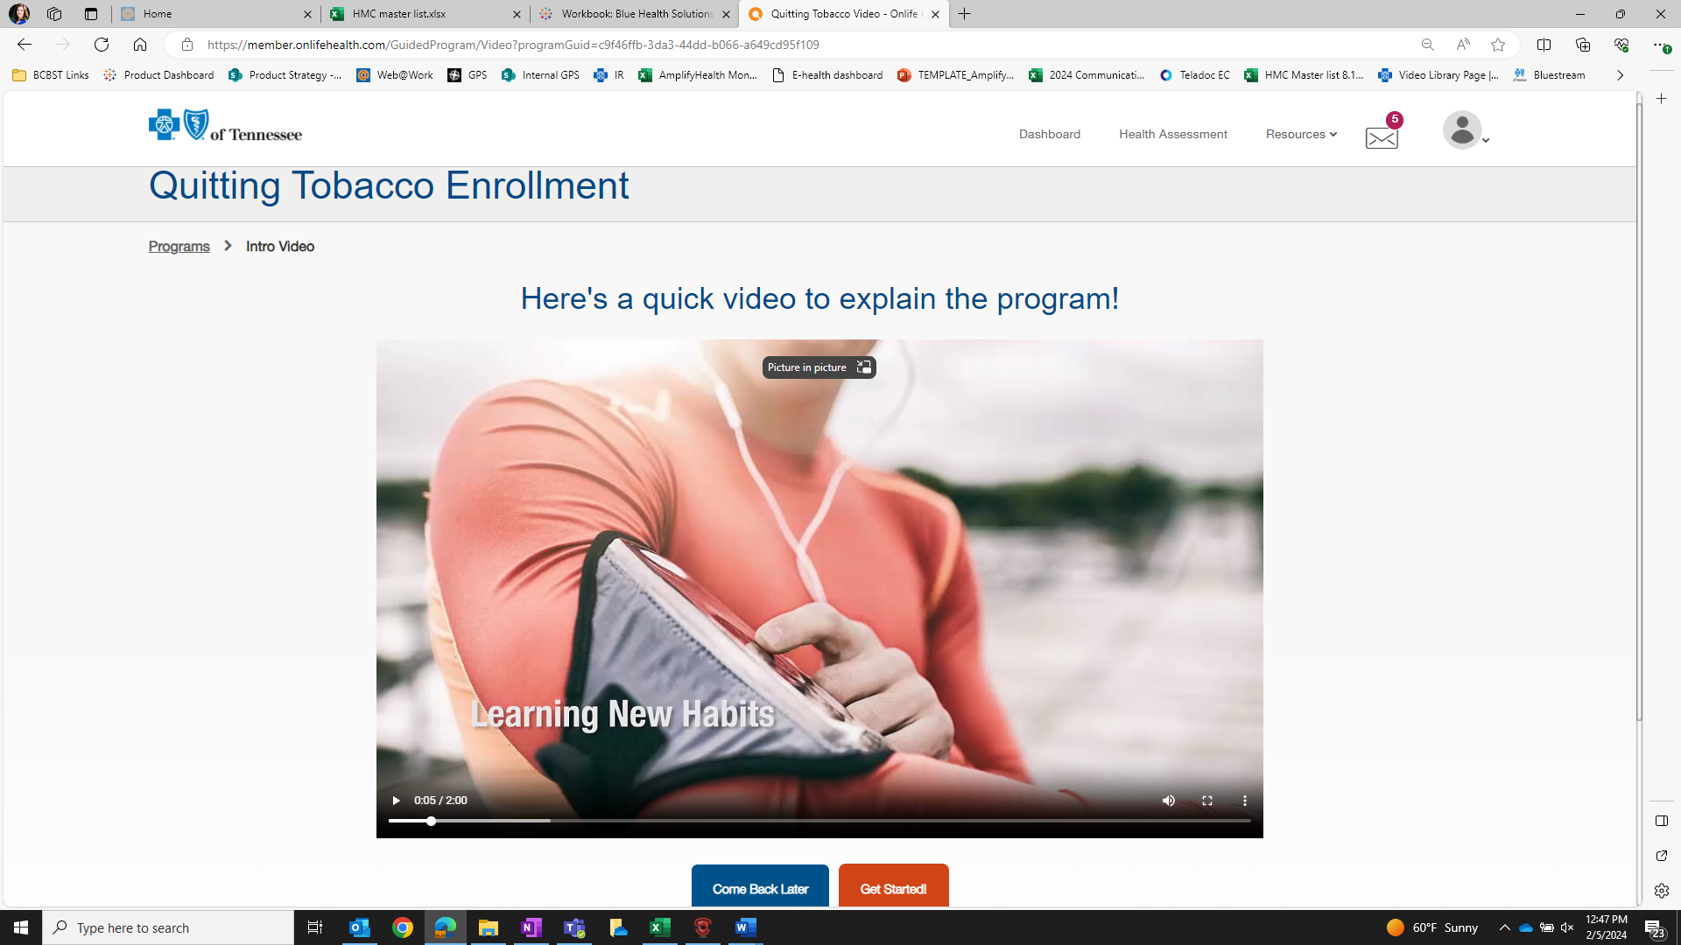

**If you’d like to earn a completion certificate, you must complete the entire six-week program and final assessment**. Once you complete the program, click on ‘Certificates’ at the bottom right corner of the home screen or on the ‘More Features For You’ tile under ‘Browse All Activities’.

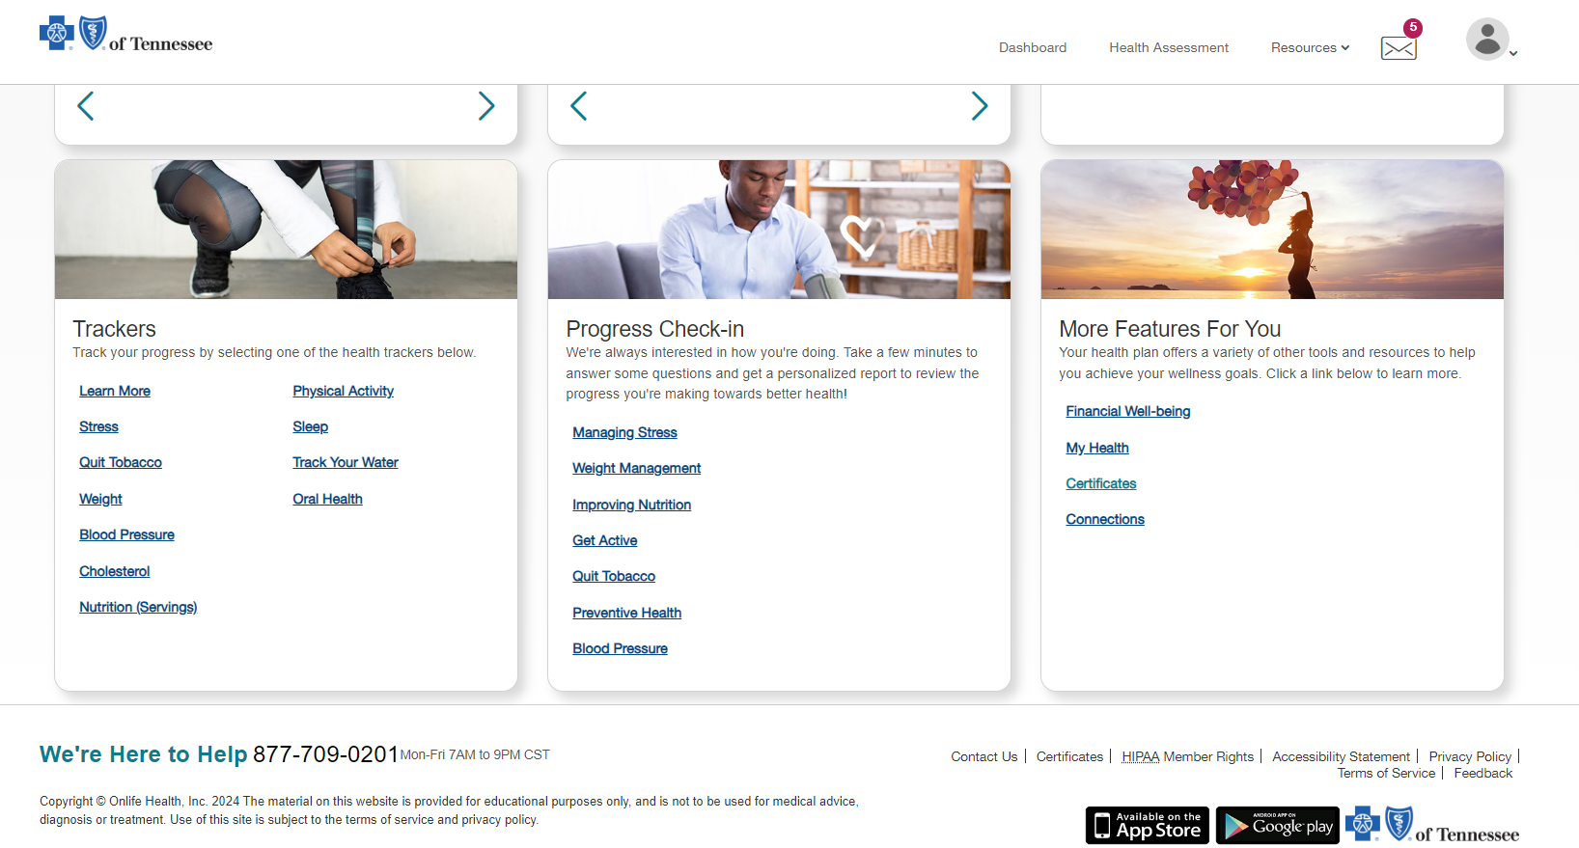

Click on ‘View Certificate’ to print or download your certificate. Click on ‘Email Certificate’ to email it.

