Hello **[NAME]**,

My name is **[NAME]**, I am a certified Assistive Technology Professional (ATP) practicing in the **[LOCATION]** area. I have over **[NUMBER OF YEARS]** years of experience in the **[COMPLEXT REHAB TECHNOLOGY OR OTHER APPLICABLE]** industry. **[INSERT SUMMARY OF CAREER HERE – USE AS AN EXAMPLE.** **I began my career with Home Medical Devices in Anchorage, Alaska as a service technician. I then moved on to managing the respiratory department for several years and then returned to complex rehab technology (CRT) as an ATP. I moved to Washington two years ago with my family and began working for National Seating & Mobility in 2021.]**

National Seating & Mobility (NSM) has many tools and resources to partner with Doctors, Therapists, and Clinicians to provide an efficient, streamlined approach. We pride ourselves as not only having the fastest delivery rates, but also the highest customer service satisfaction rankings in the industry.

If your team would like further information, please feel free to contact me and I would love the opportunity to meet you and your staff – in a safe, socially distanced way of course!

Find more information on National Seating & Mobility here:

[NSM Website](https://www.nsm-seating.com/)

[Overview Brochure](https://www.nsm-seating.com/content/uploads/2020/07/NSM-Brochure-Overview-8.5x11.pdf)

[Mobility Brochure](https://www.nsm-seating.com/content/uploads/2020/07/NSM-Brochure-Accessibility-CRT-8.5x11.pdf)

[Home & Vehicle Accessibility Brochure](https://www.nsm-seating.com/content/uploads/2020/07/NSM-Brochure-Accessibility-LIGHT-8.5x11-2.pdf)

[Service & Repair Brochure](https://www.nsm-seating.com/content/uploads/2020/07/NSM-Brochure-Accessibility-Service-8.5x11.pdf)

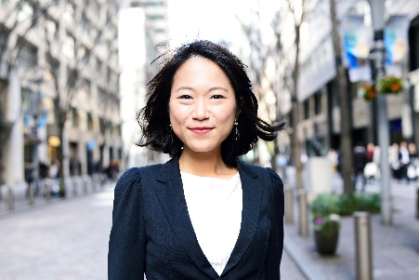

**[REPLACE WITH HEADSHOT]**

|  |  |
| --- | --- |
|  | **FIRST LAST** CERTIFICATIONS  **c.** 111.111.1111 | **f.** 111.111.1111 [www.nsm-seating.com](http://www.nsm-seating.com/)  **MOBILITY** ● **ACCESSIBILITY** ● **SERVICE** |